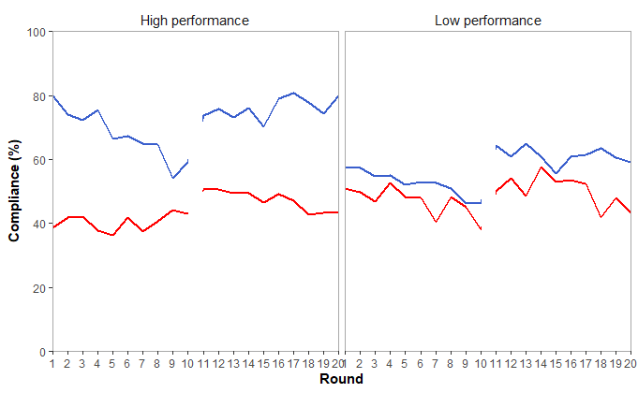

**High-performance associations**

**Low-performance associations**

Non-enforced

Peer-enforced

Non-enforced

Peer-enforced

**Compliance (%)**

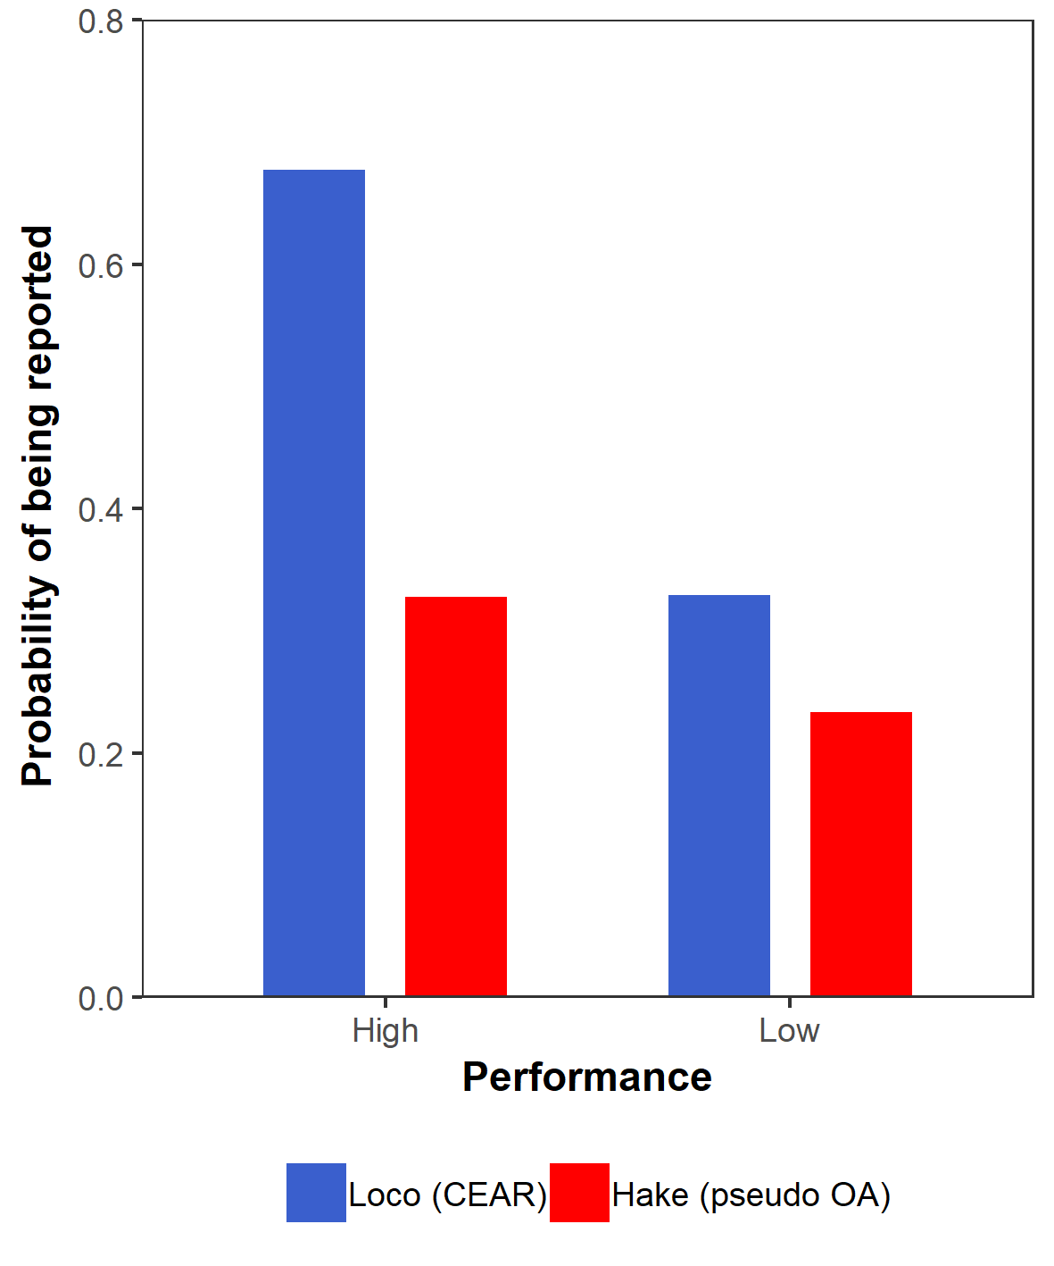

Hake (*pseudo* OA)

Loco (CEAR)

0 1 2 3 4 5 6 7 8 9

0 1 2 3 4 5 6 7 8 9

0 1 2 3 4 5 6 7 8 9

0 1 2 3 4 5 6 7 8 9

100

80

60

40

20

0

**Round**